CS6314.002- Team5- RV Rentals

Hao Si (hxs180013), Feng Mi(fxm150930)

**Project Title**: RV Rental

**Website Name**: Dallas RV Rental

**Project Description**:

Dallas RV Rental is a website-based RV rental company and it mainly focuses on the RV rental on the Internet. Users can easily see the details about the Rvs that are currently available and set up online orders. If the Rvs user wants to rent it is currently unavailable, they can choose to add to the wish list. User can also know what they bought before by seeking their history. For the admin, he can easily maintain the inventory by adding the new RVs or delete the currently RVs.

**Database design**:

We choose to use MongoDB. Here is the information about our MongoDB data model:

5 Collections:

* Rvs which record basically the details of each RV.
* Accounts which record the auth info about the users. For the password, we just record the hash value of the password. We do not store the raw input of the user password to better protect the user privacy.
* Carts which record the item which users save for buying in the future.
* Purchase history records every purchase for every user.
* Wishlist record liked Rv of every user.

**Languages/frameworks:**

HTML, CSS, Javascript, JQuery, Node.js ,E­­­xpress

**Screenshots for the Main function:**

**List products and search, filter, paging function:**

**Shopping cart and its edit feature:**

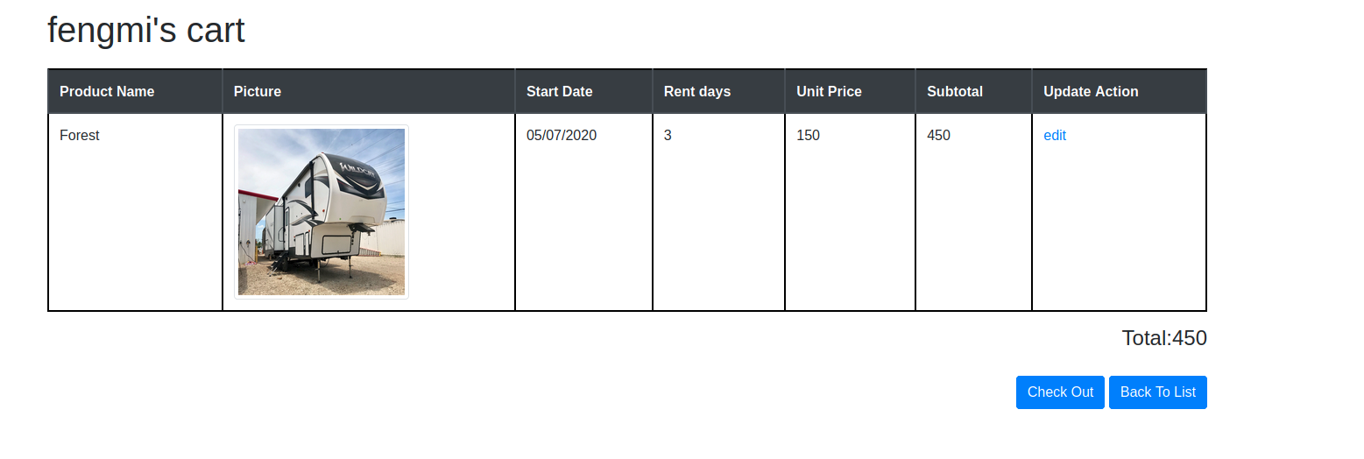

**Rv Detail Page:**

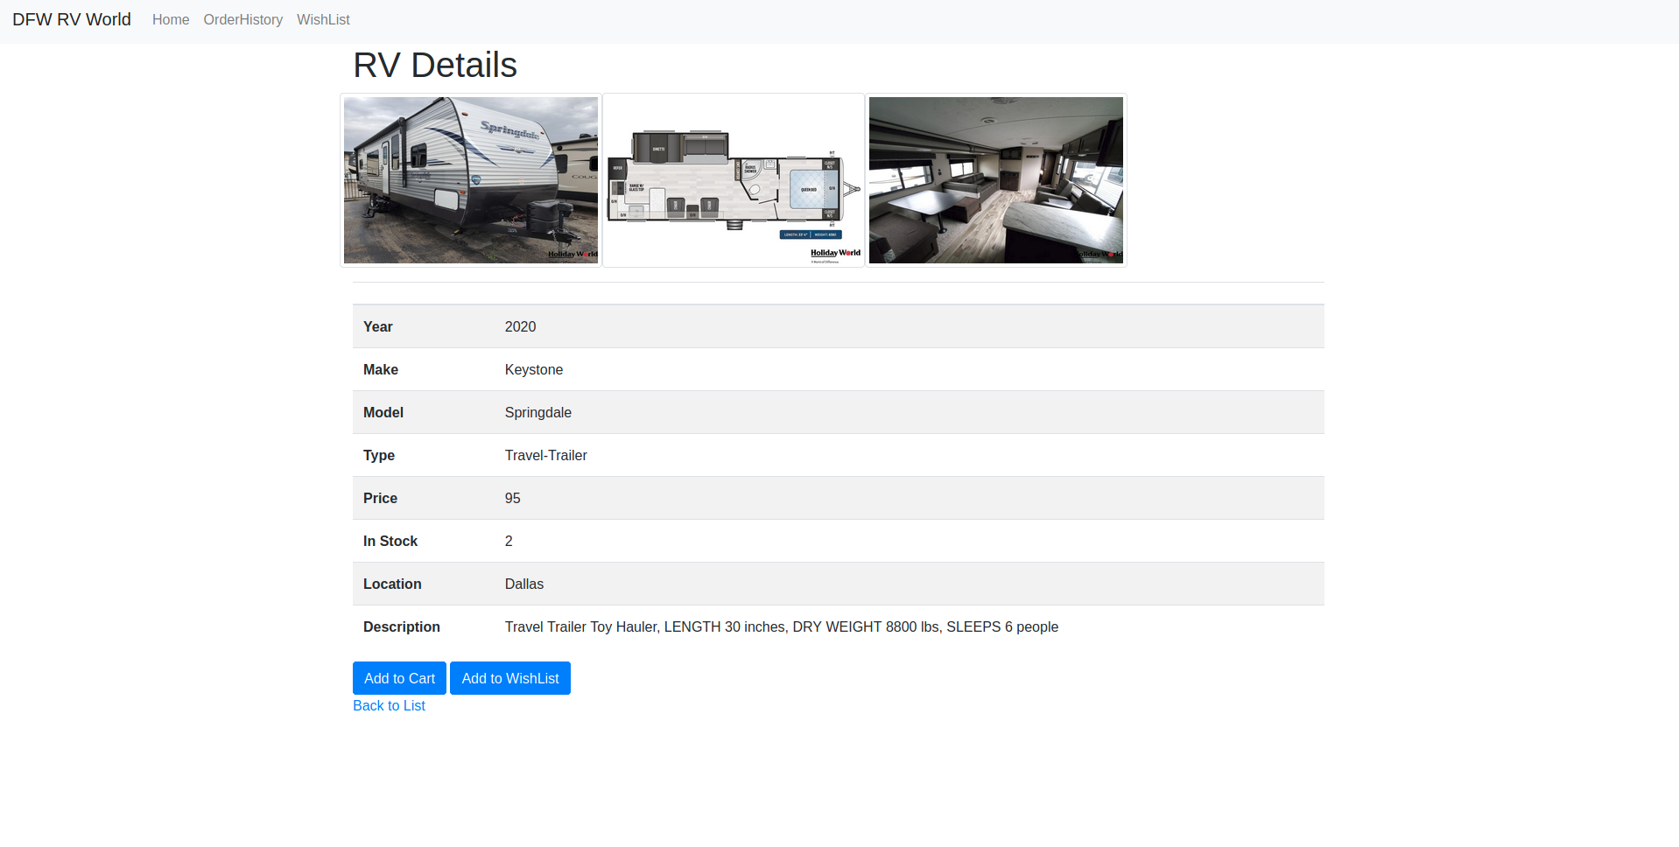

**Admin Function:**

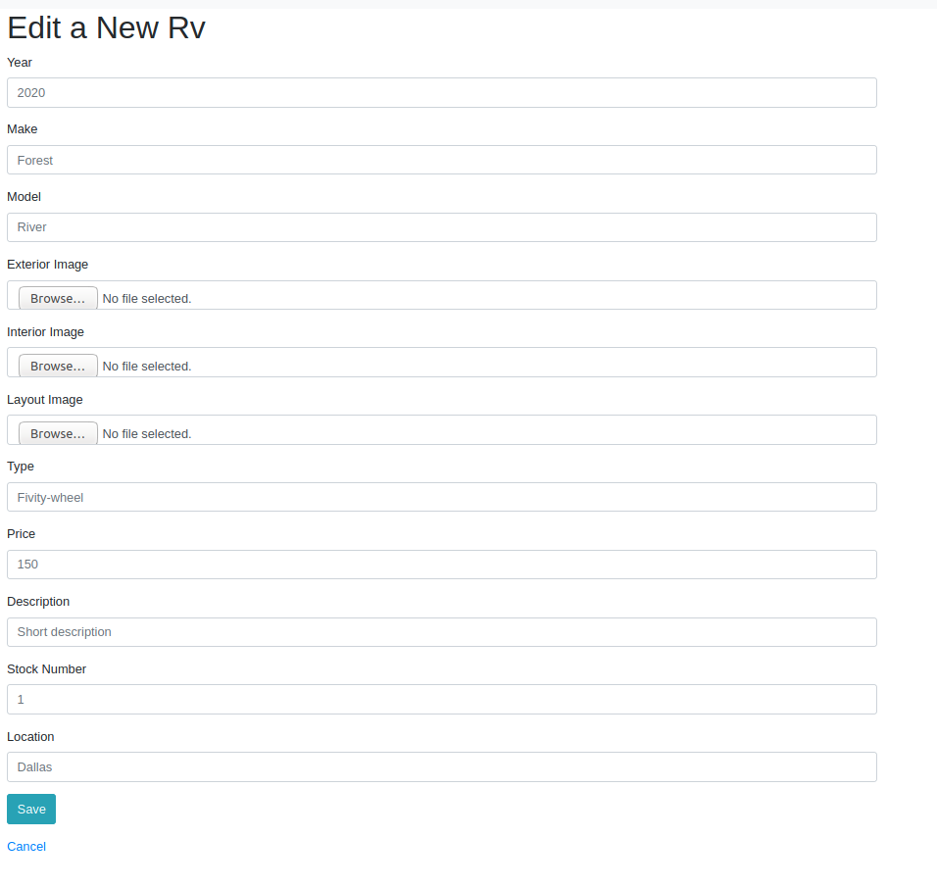

**User sign up and its validation method:**

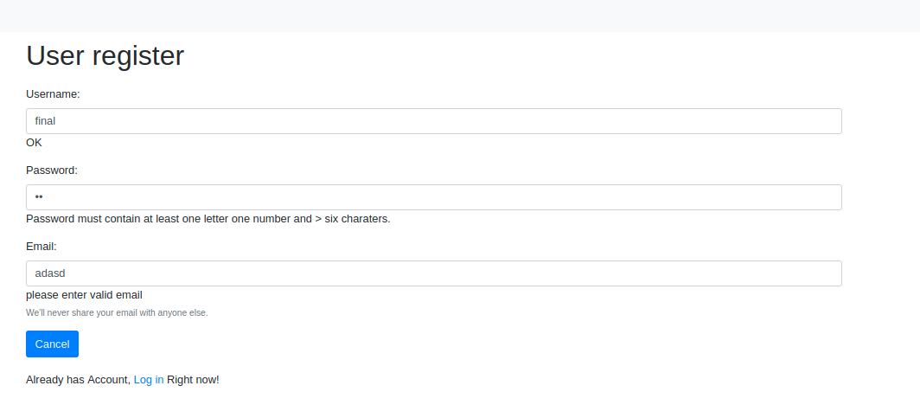

**Order History and Wish List:**

**Team members:**

Feng Mi fxm150930

Hao Si hxs180013

**Work division:**

Hao Si:

1. List products / Paging
2. History of purchases or saved lists
3. Admin User
4. Soft delete feature
5. Design mongoDB data model and create some data
6. Maintain the GitLab repo

Feng Mi:

1. Implement the function for user sign up, user login
2. Cart / Checkout / Update feature
3. Design the mongoDB data model and create some data
4. Maintain the GitLab repo